Lab Sheet 1 — DDL Commands: CREATE, ALTER and DROP
1. Create a database named CollegeDB.
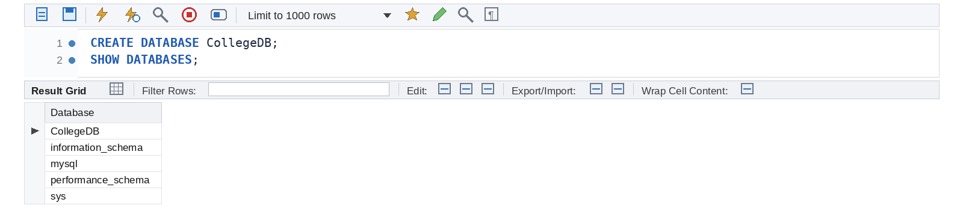
2. Create a Student table with columns: Student_ID, Name, Age, Course, and City.
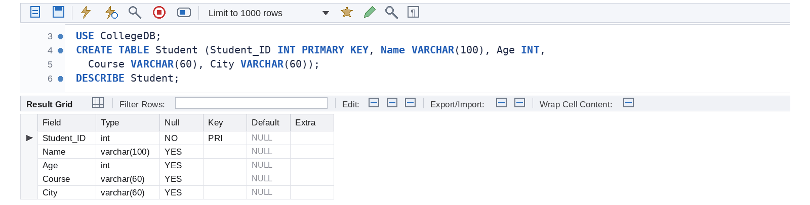
3. Create an Employee table with Emp_ID, Emp_Name, Department, and Salary.
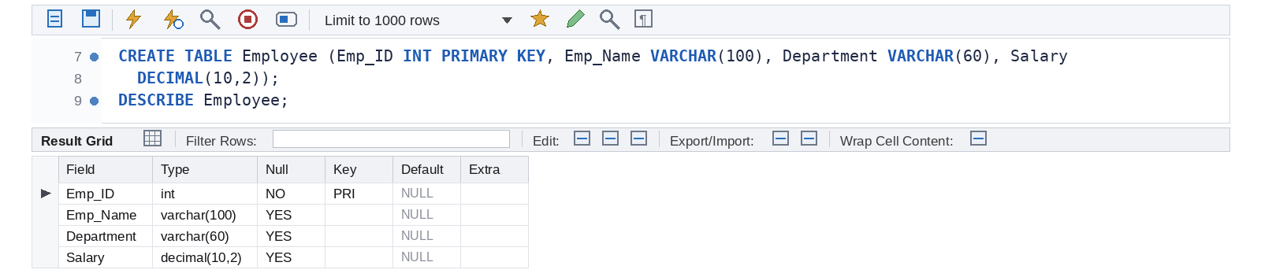
4. Create a Department table with Dept_ID, Dept_Name, and Location.
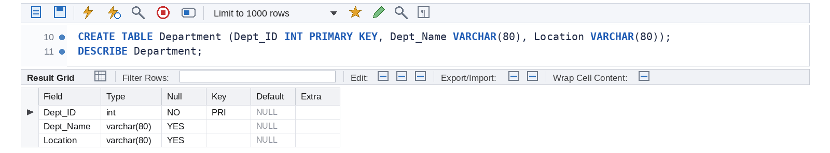
5. Create a Product table with Product_ID, Product_Name, Price, and Quantity.
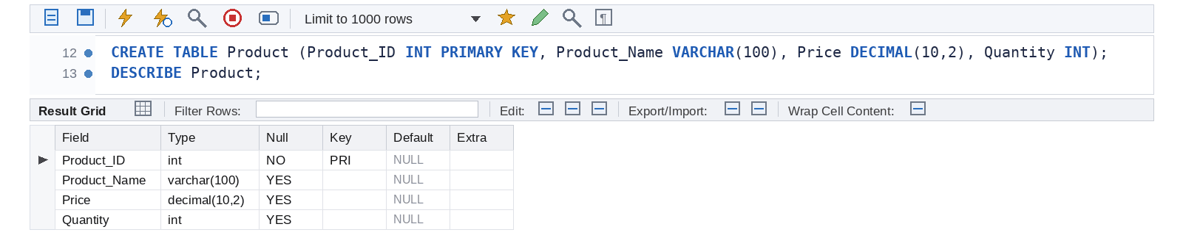
6. Create a Customer table with Customer_ID, Customer_Name, Email, and Phone.
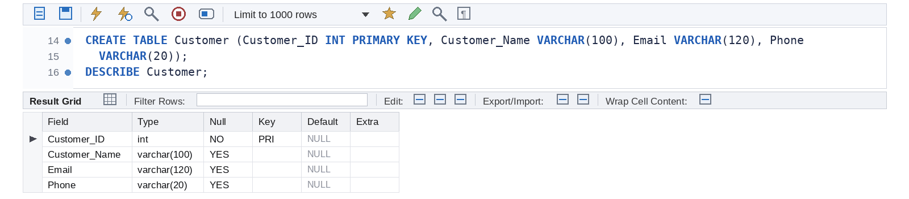
7. Create a Course table with Course_ID, Course_Name, Duration, and Fees.
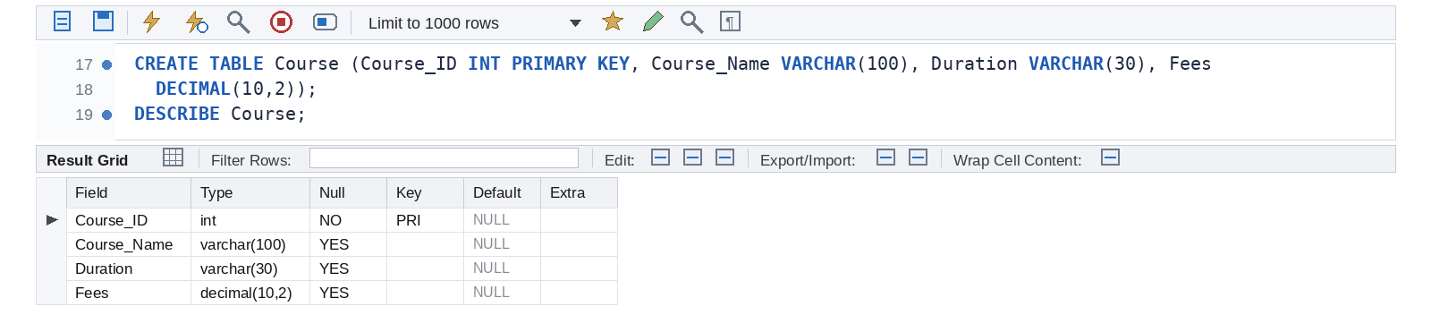
8. Create a Faculty table with Faculty_ID, Faculty_Name, Subject, and Salary.
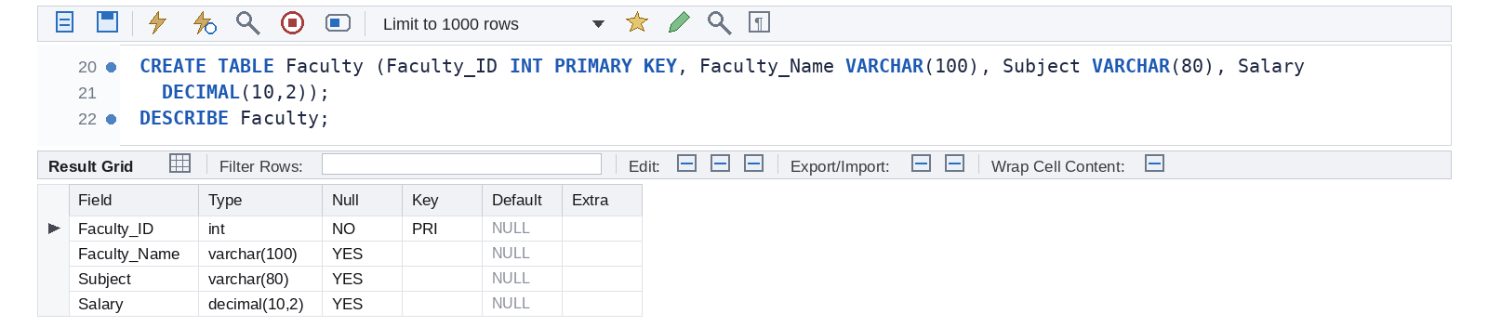
9. Create a Library table with Book_ID, Book_Name, Author, and Price.
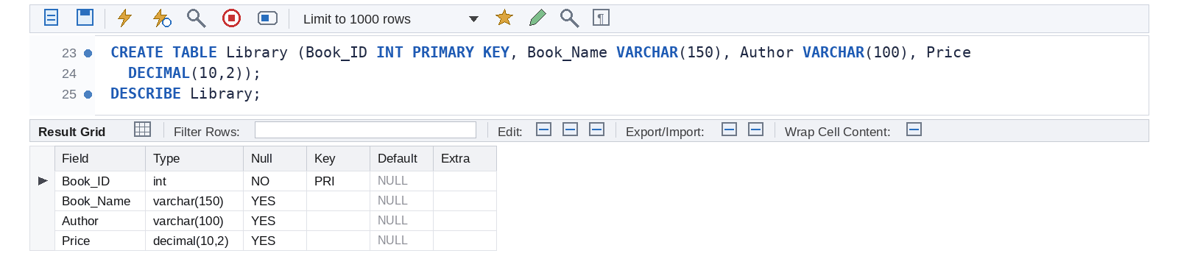
10. Create a Department table with Dept_ID as the Primary Key.
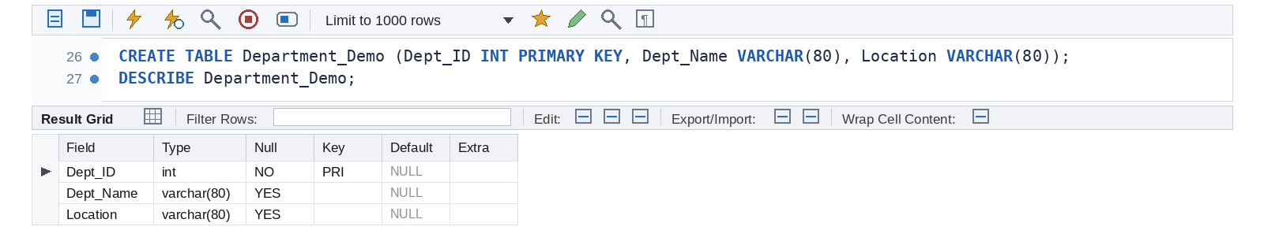
11. Create a Student table with Student_ID as the Primary Key and Name as NOT NULL.
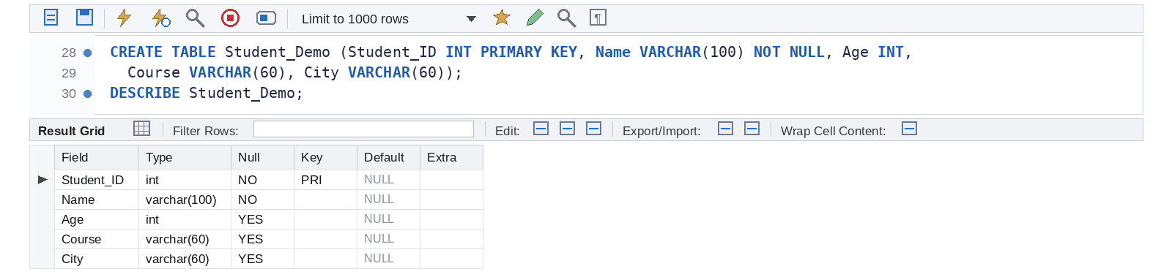
12. Create an Employee table with a UNIQUE constraint on Email.
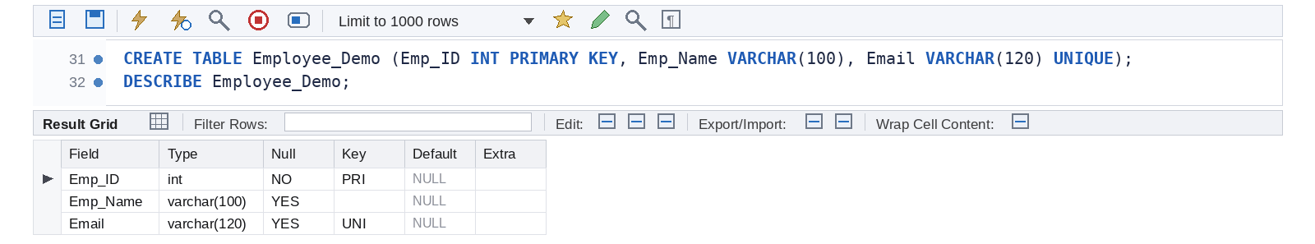
13. Create a Product table with a CHECK constraint that Price > 0.
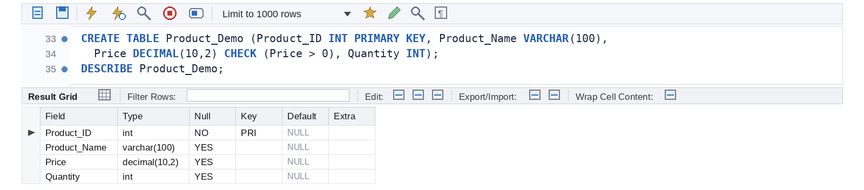
14. Add a new column Email to the Student table using ALTER TABLE.
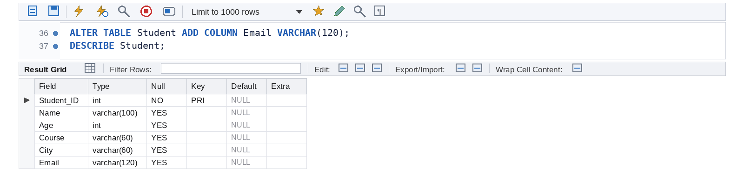
15. Add a Phone column to the Student table.
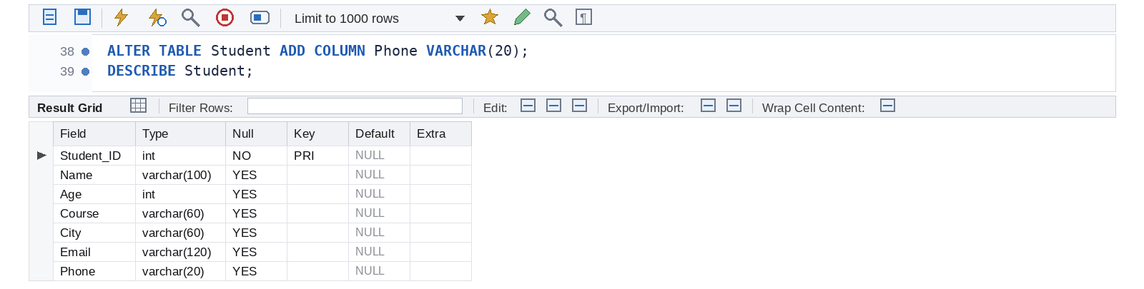
16. Modify the datatype/size of the Name column in the Student table.
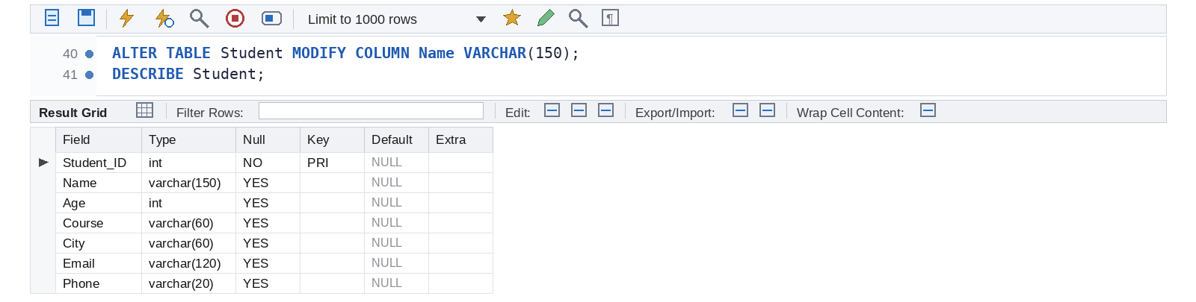
17. Rename the Student table to Student_Details.
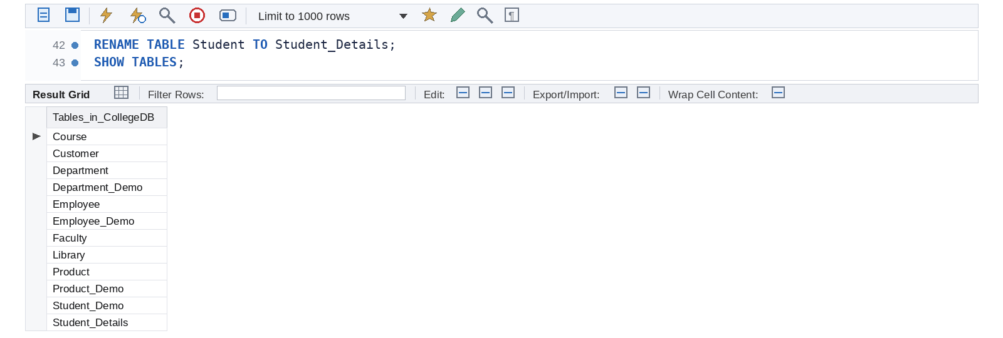
18. Rename the column City to Address.
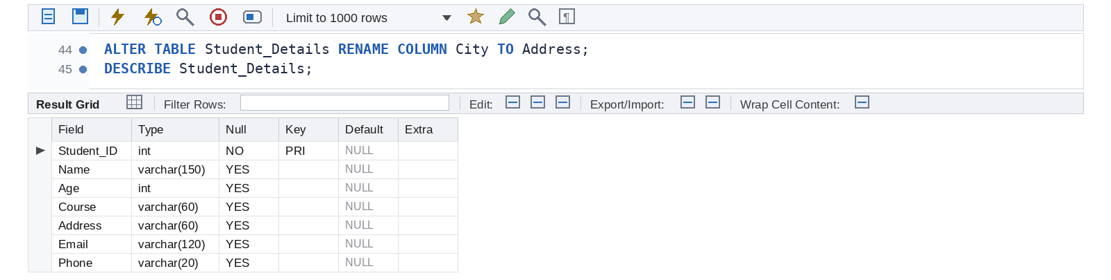
19. Add a Salary column to the Employee table.
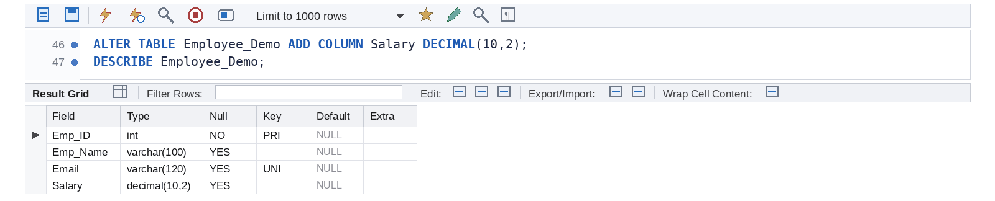
20. Drop the Phone column from the Student table.
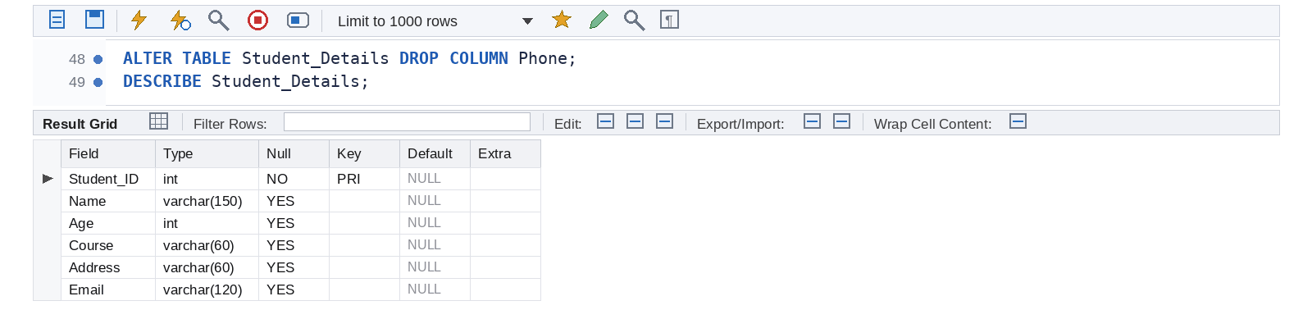
21. Drop the Email column from the Student table.
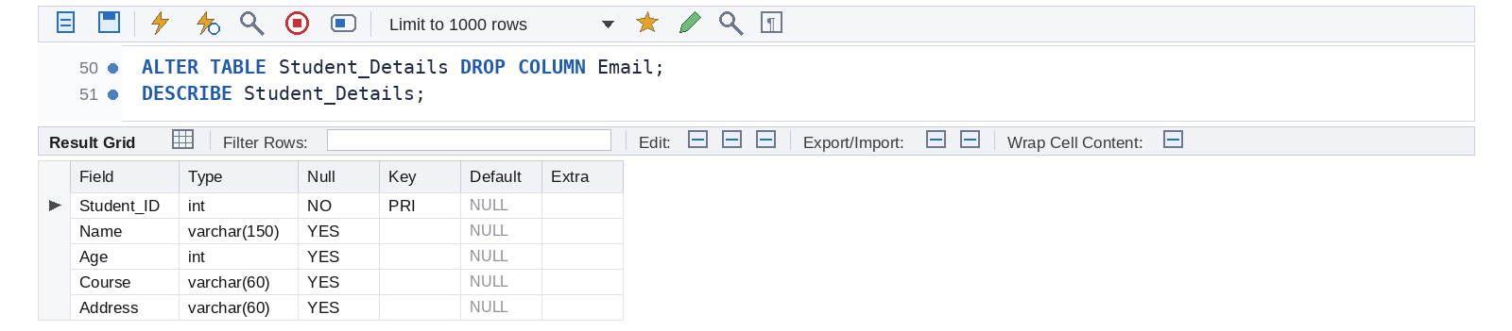
22. Remove all records from a table using TRUNCATE.
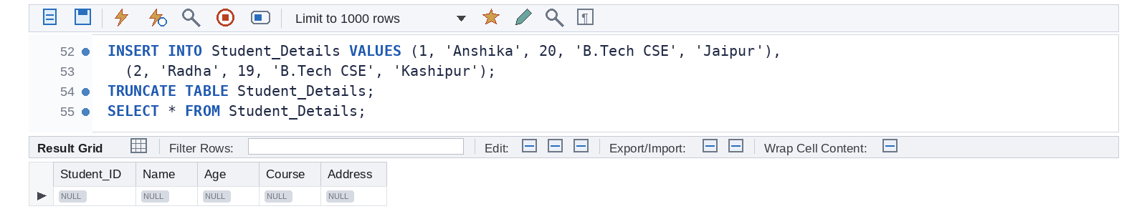
23. Drop the Course table from the database.
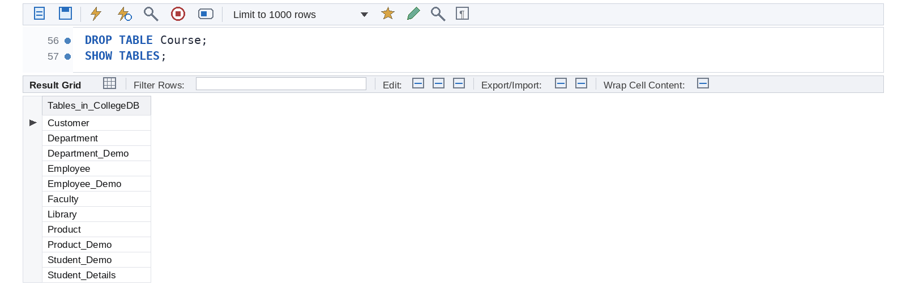
24. Drop the Customer table from the database.
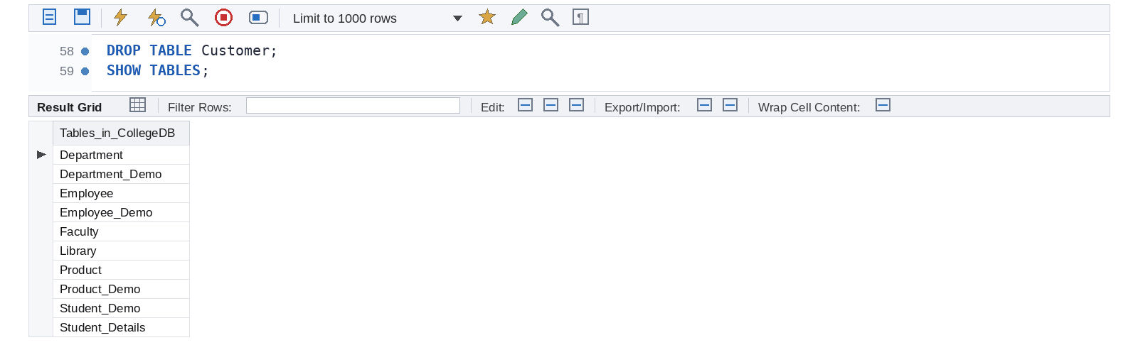
25. Create a complete Student table using Primary Key, NOT NULL, UNIQUE and CHECK constraints.
